EXPERIMENT NO. 8
CASE STUDY ON STUDY OF ENVIRONMENTAL POLLUTION
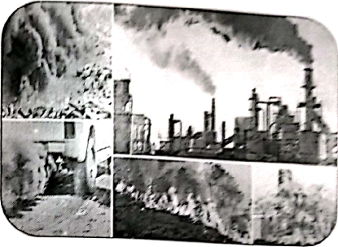
TOPIC: AIR POLLUTION IN MUMBAI CITY AND ITS CONTROL MEASURES
1. INTRODUCTION
Mumbai, India's financial capital and one of the most densely populated cities in the world, is facing a growing challenge: air pollution. Rapid urbanization, increased vehicular traffic, industrialization, and population growth have contributed to declining air quality in the city.
AIR POLLUTION
Air pollution is defined as the presence of harmful or excessive quantities of substances in the air we breathe. These pollutants can be solid particles, liquid droplets, or gases such as carbon monoxide, sulfur dioxide, nitrogen oxides, ozone, and particulate matter (PM). Air pollution affects human health, ecosystems, and the climate.
2. SOURCES OF AIR POLLUTION IN MUMBAI
The main contributors to air pollution in Mumbai include:
- Vehicular emissions: Mumbai has over 38 lakh (3.8 million) registered vehicles. Older vehicles and traffic congestion lead to high emissions of PM, NOx, and CO.
- Construction and demolition: Ongoing infrastructure projects generate large quantities of dust and suspended particles.
- Industrial activities: Power plants and industries, especially in areas like Chembur and Mahul, emit smoke and chemical pollutants.
- Waste burning: Open burning of garbage and landfill fires (e.g., Deonar dump yard) release toxic gases and particulate matter.
- Domestic fuel use: In slums and low-income areas, kerosene and wood burning adds to indoor and outdoor pollution.
3. TYPES OF AIR POLLUTION
- Particulate Matter (PM₂.₅ & PM₁₀): Fine dust particles that can enter the lungs and bloodstream.
- Gaseous pollutants: Including carbon monoxide (CO), sulfur dioxide (SO₂), nitrogen oxides (NOx), and ozone (O₃).
- Smog: A mixture of smoke and fog, often observed during winter months.
- Volatile Organic Compounds (VOCs): Emitted from fuels, paints, and industrial processes.
4. DATA AND STATISTICS
- According to a 2025 report under the National Clean Air Programme (NCAP), Mumbai saw a 44% reduction in PM₁₀ levels compared to 2017–18.
- However, local hotspots like Deonar, Sion, and Kandivali East still exceed national air quality standards.
- In January 2023, Mumbai recorded “very poor” air quality (AQI 300–400) for more than 20 days.
- PM₂.₅ levels often cross double the permissible limit (i.e., 40 µg/m³), with WHO’s safe limit being just 5 µg/m³.
5. HEALTH IMPACTS OF AIR POLLUTION
Air pollution has a direct impact on the health of Mumbai's population:
- Increases respiratory issues: asthma, bronchitis, coughing, and shortness of breath.
- Children and elderly are most affected due to weaker immune systems.
- Prolonged exposure can lead to cardiovascular diseases, lung cancer, and reduced life expectancy.
6. CONTROL MEASURES TAKEN
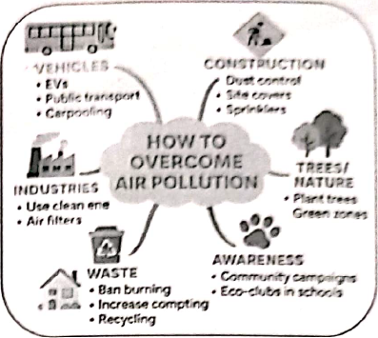
- Dust control: Water sprinklers, fogging machines, and green covers at construction sites.
- Vehicle emission checks: Promotion of CNG and electric vehicles, scrappage of old diesel vehicles.
- Public transport upgrade: Expansion of BEST electric buses and metro rail to reduce private vehicle use.
- Waste management: Ban on open garbage burning; processing of waste in scientific ways.
- Green initiatives: Plantation drives and development of green corridors in polluted zones.
- Air monitoring: Installation of real-time air quality monitoring stations across the city.
7. RECOMMENDATIONS
- Localized solutions: Focus on area-wise pollution sources and tailor-made interventions.
- Awareness programs: Educating citizens on pollution sources and preventive measures.
- Research and innovation: Encouraging green technologies and eco-friendly construction practices.
8. CONCLUSION
Air pollution in Mumbai is a serious environmental and public health concern. While significant progress has been made through the NCAP and municipal efforts, challenges remain due to rapid development and population pressure. A multi-sectoral and community-driven approach is needed to ensure cleaner air, healthier lives, and sustainable urban development. Continuous monitoring, public participation, and policy enforcement will be key to overcoming this pressing issue.
TERNA ENGINEERING COLLEGE, NERUL
TITLE | CASE STUDY ON ENVIRONMENTAL POLLUTION
NAME | Avdhut Parish Madhavi
CLASS / BATCH | COMP / SEM III / C2 | ROLL NO. C-60
SIGN

